**Advanced Mathematics – WS2021 – Lab 11**

Tzu-Hsuan Lai

Matrikelnummer: 3509427

Exercise 1 – bathymetric data The date set depths.txt contains the bathymetric depths in meters for an ocean basin part. Find the mean depth, the standard deviation and the 95% confidence interval on the mean depth. What is the probability that a random depth measurement will be shallower than -4000m?

Mean: $-4393.7 (m)$

Standard deviation: $909.5 (m)$

the 95% confidence interval on the mean depth:

$$\left[mean-1.96σ, mean+1.96σ\right]=[-6176.4, -2611.1]$$

$$at x=-4000, we have z=\frac{x-μ}{σ}=\frac{-4000-\left(-4393.7\right)}{909.5}=0.43$$

from the table, when $z=0.43, P=0.6664.$

$$∴P\left(x≤-4000\right)=1-0.6664=0.3336$$

Exercise 2 – plane booking

A small plane doing the Stuttgart-Frankfort link can accommodate 30 people every day. Statistics show 20% of customers who have booked do not come. Let X be the random variable: “number of customers who are present at the counter among 30 people who have reserved”. What is the law of X (only the general form will be given)? What is its expectation and standard deviation? Give a confidence interval at the 95% threshold, making it possible to estimate the number of customers to expect.

The law of X is a binomial probability distribution.

$$P\left(X\right)=0.8$$

$$E\left(X\right)=nP=24$$

$$var\left(X\right)=σ^{2}=nP\left(1-P\right)=4.8$$

$$σ=2.19$$

confidence interval at the 95% threshold

$$\left[μ-1.96σ,μ+1.96σ\right]=[19.70, 28.29]$$

We can expect that there’ll be 20 to 28 reserved customers.

Exercise 3 – water contents of soils

The water contents of soils (in volume %) were measured at two sites A and B around Montpellier, France. There are reproduced in soilwater.txt. At the 99% level of confidence, do the soils at the two sites have different water content?

Mean value of A = 11.4153

Mean value of B = 10.6513

$$σ_{A}=2.0814; σ_{B}=3.0275$$

$H_{0}:$ $μ_{A}=μ_{B}$

$H_{a}:$ $μ_{A}≠μ_{B}$

$$t=\frac{11.4153-10.6513}{\sqrt{\frac{{2.0814}^{2}}{72}+\frac{{3.0275}^{2}}{80}}}=1.8277$$

degree of freedom

$$df=\frac{\left(\frac{{2.0814}^{2}}{72}+\frac{{3.0275}^{2}}{80}\right)}{\frac{1}{72-1}\left(\frac{{2.0814}^{2}}{72}\right)+\frac{1}{80-1}\left(\frac{{3.0275}^{2}}{80}\right)}=76.0494 use df=76$$

two-tailed p-value is between 0.1 and 0.05

$$p-value≥0.01, accept H_{0}$$

Exercise 4 – toxic algae on beaches

We are interested in the problem of toxic algae that reaches certain beaches in France. After study, we note that 10% of beaches are affected by this type of algae and we want to test the influence of new chemical releases on the appearance of these algae. For that, 50 beaches close to the chemical rejection zones are observed. We then count 10 beaches affected by the harmful algae. Can you answer the question: “With the risk α = 0.05, have the chemical releases significantly changed the number of beaches affected?”

$$H_{0}:P≤10\%$$

$$H_{a}:P>10\%$$

$$\overline{P}=\frac{10}{50}=0.2$$

$$z=\frac{\overline{P}-P_{0}}{\sqrt{\frac{P_{0}\left(1-P_{0}\right)}{n}}}=\frac{0.2-0.1}{\sqrt{\frac{0.1\left(1-0.1\right)}{50}}}=2.36$$

$$z_{0.05}=1.645, z>z_{0.05} ∴H_{0} rejected$$

Exercise 5– sulfur dioxide emissions

An environmental scientist measures the sulfur dioxide emissions from an industrial plant over an 80-day period. The amounts in tons per day are given in the file *sulfur.txt*. Bin the data using the categories less than 10, 10-15, 15-20, 20-25, 25 and above. Plot the histogram and indicate the counts. The scientist wonders if the emissions are well described by the expected normal distribution. What are the mean and standard deviation for the raw data? The scientist decides to use a χ²test. What are the expected counts in each bin? Test whether or not the binned data are indistinguishable from a normal distribution at the 95% level of confidence. Should the scientist reject H0?

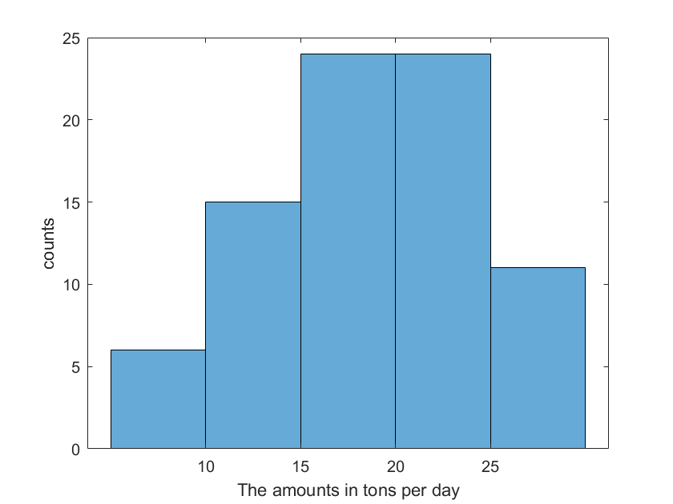

Mean of the raw data: 18.8275

Standard deviation of the raw data: 5.7195

Test data:

$$18.83+5.72z_{1}=10 z_{1}=-1.54 P=0.0618$$

$$18.83+5.72z_{2}=15 z_{2}=-0.67 P=0.2514$$

$$18.83+5.72z_{3}=20 z_{3}=0.20 P=0.5080$$

$$18.83+5.72z_{4}=25 z_{4}=1.08 P=0.8599$$

$There$ should be 0.0618 $×80=4.94$ numbers of data less than 10; 15.17 numbers of data between 10 and 15; 20.53 numbers of data between 15 and 20; 28.15 numbers of

|  |  |  |
| --- | --- | --- |
| interval | Oberserved counts $$(c_{i})$$ | Expected counts $$(e_{i})$$ |
| Less than 10 | 6 | $$0.0618×80≈5$$ |
| 10-15 | 15 | $$\left(0.2514-0.0618\right)×80≈15$$ |
| 15-20 | 24 | $$\left(0.5080-0.2514\right)×80≈21$$ |
| 20-25 | 24 | $$\left(0.8599-0.5080\right)×80≈28$$ |
| 25 and over | 11 | $$80-(5+15+21+28)=11$$ |

$H_{0}:$ The emissions are well described by the normal distribution with mean 18.8275 and standard deviation 5.7195

$H_{a}:$ The emissions do not have a normal distribution with mean 18.8275 and standard deviation 5.7195

|  |  |  |
| --- | --- | --- |
| interval | $$c_{i}-e_{i}$$ | $${\left(c_{i}-e_{i}\right)}^{2}/e_{i}$$ |
| Less than 10 | 1 | 0.20 |
| 10-15 | 0 | $$0$$ |
| 15-20 | 3 | $$0.43$$ |
| 20-25 | $$-4$$ | $$0.57$$ |
| 25 and over | 0 | $$0$$ |
|  |  | $$χ^{2}=1.2$$ |

$$Degree of freedom=5-2-1=2$$

With $χ^{2}=1.2$, the area in the upper tail greater than 0.10. Thus, we know that the p-value is greater than 0.10. With p-value>0.1, the hypothesis that the probability distribution for the sulfur dioxide emissions is a normal probability distribution cannot be rejected. The normal probability distribution may be applied to assist in the interpretation of emissions.